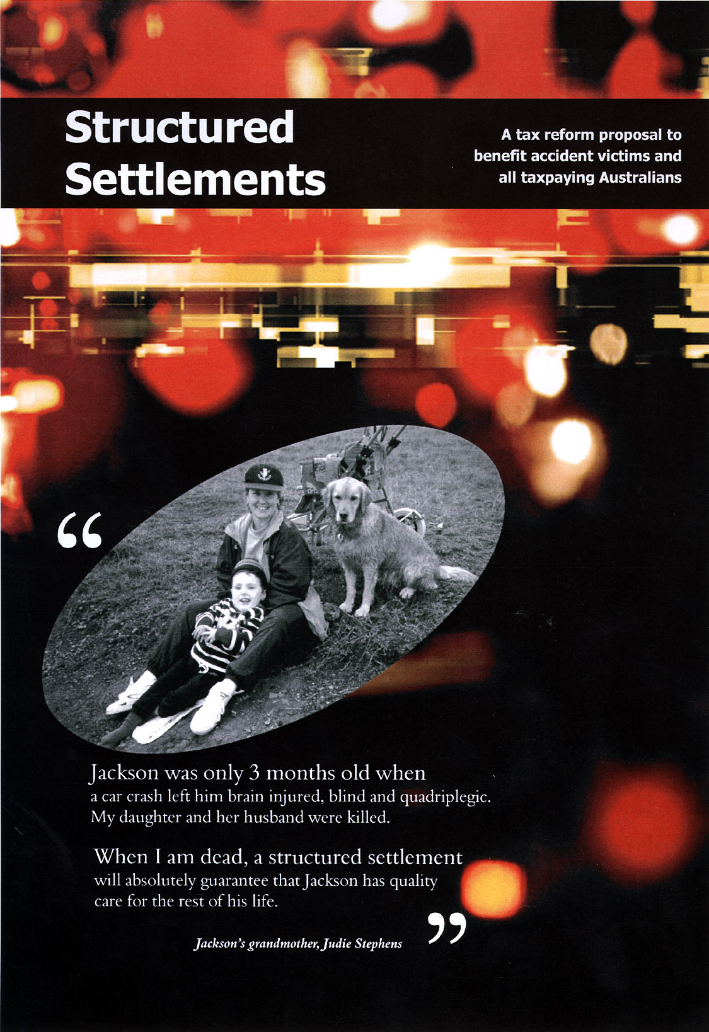

“Jackson is unlikely to ever be able to work and will need care for the rest of his life.

Our Government must act quickly to ensure that structured settlements are made available to protect people like Jackson.”

Media and Hansard Reporting

On Friday 25 June 1999, the Hon. Danna Vale MP, Federal Member for Hughes, launched this proposal to the media at Parliament House, Canberra.

Danna Vale has spoken to our Prime Minister and in the Federal Parliament (House of Representatives) promoting the economic and social sense of structured settlements. See House Hansard “Tax Reform: Structured Settlements”, 23 June 1999, p.7252.

Senator Alan Ferguson has also spoken in the Federal Parliament (Senate) promoting structured settlements. See Senate Hansard “Compensation: Structured Settlements”, 25 August 1999, p.7486.

Media reporting has included:

12 March 1999: ABC Radio National
20 April 1999: John Laws, Foxtel TV
22 June 1999: The Age newspaper, Melbourne, p.7
24 June 1999: The 7.30 Report, ABC TV
26 June 1999: The Canberra Times newspaper, p.3
26 June 1999: The Sydney Morning Herald newspaper, p.13
26 June 1999: 2UE Radio 11.30am
26 June 1999: News at Five, Channel 10 National TV
15 July 1999: St George & Sutherland Shire Leader newspaper, p.8

6 September 1999: ABC Radio South Australia, 4.12pm

“I encourage you to lobby ensuring social and economic justice prevails”
Jackson’s grandmother, Judie Stephens

community website: www.daretodo.asn.au
e-mail: daretodo@daretodo.asn.au

You may contact Judie mobile 0419 393 393

Structured Settlements

A tax reform proposal to benefit accident victims

And all tax paying Australians

June 1999

This proposal is made by the Structured Settlement Group

The Group is the national representative body of the supports of structured settlements in Australia. Membership includes the national representative bodies of all key stakeholders, including the Australian Plaintiff Lawyers Association, Injuries Australia, the Insurance Council of Australia, the Law Council of Australia and United Medical Protection.

The Group has been formed to speak with one voice to the Federal Government on the issue of structured settlements. The Group seeks to introduce structured settlements to Australia.



Postal address: The Structured Settlement Group GPO Box 4674 SYDNEY NSW 1044
Enquiries: Jane Ferguson, Ph. 0409 209 747, Fax 0409 209 855, Email: janeferguson@bigpond.com

The Group would like to thank Judie Stephens daretodo@nsw.bigpond.net.au for her tireless law reform efforts.

Supported and published by Motor Accidents Authority.

Editorial consultant – Steve Freeth
Design and production – Pru Whitwell

Structured Settlements – the proposal

STRUCTURED SETTLEMENTS
THE PROPOSAL SUMMARY

Generally speaking, common law lump sum compensation for personal injury is received by a claimant tax-free, whereas periodic payments of compensation are subject to income tax. The taxable nature of periodic payments as opposed to lump sums is a strong disincentive to their use in settling common law personal injury claims.
This submission asks the Australian Government to encourage the use of structured settlements by making structured settlement payments of compensation tax-free. This will save the Government millions of dollars each year and benefit injured people and insurers.
Structured settlements are a way of paying common law compensation periodically. Instead of a single lump sum, claimants would receive a smaller up-front lump sum combined with ongoing, tax-free, periodic payments for life. This arrangement offers seriously injured people greater long-term financial security.
Structured settlements are good for both claimants and defendant insurers. All
compensation stakeholders in Australia unanimously support their introduction as a voluntary settlement option in Australia. Structured settlements are also supported by international precedent in the USA, the UK and Canada.

Structured settlements encourage accident victims to secure their own financial independence. Without tax reform, accident victims will continue to choose lump sum compensation.

Lump sum compensation can be difficult to manage and easy to spend too quickly. When the money runs out, seriously injured people, who are unable to generate an alternative income, have no option by to seek financial support from the Government through Social Security payments and Health care benefits.

The use of structured settlements will reduce the risk of seriously injured accident victims becoming reliant on Government welfare.

The introduction of a tax incentive for structured settlements will save the Australian Government millions of dollars each year. It is also consistent with existing Australian Government policies aimed at encouraging periodic payments and income security.

Structured Settlements - index

Index

What are structured settlements? 7
Why we need a lump sum alternative 8
What the Government needs to do 11
Real life stories 13
The economic case for structured settlements 16
Unanimous support for structured settlements 18
Policy support for structured settlements 20

“My structured settlement protects Tiffany from other people completely taking advantage of her for the whole amount of the settlement...”
Mother of injured Tiffany (USA), see page 10

Structured Settlements – what are they, how do they work

WHAT ARE STRUCTURED SETTLEMENTS?

HOW DO THEY WORK?
A structured settlement is an alternative form of payment available to those injured people who are entitled to common law compensation. Instead of a single lump sum, structured settlements provide a smaller up-front lump sum in conjunction with lifelong periodic payments.

Structured settlements can be used wherever common law damages for personal injury are paid. This includes motor vehicle accidents, work injury, medical malpractice and public liability, but excludes statutory periodic payments.

During the settlement negotiation process, either party can suggest a structured settlement and if both parties agree the case can be settled on this basis.

The design of each structure will depend upon the individual needs of the injured person. However, overseas experience indicates that usually about 1/3 of the compensation is paid to the claimant as an up-front lump sum. The rest is used by the defendant insurer to purchase an annuity from a life insurance company for the injured person (claimant).

The annuity funds the periodic payments, which are normally payable for the life of the injured person and are indexed to inflation. There is usually a minimum guarantee period, so that if the claimant dies before that period expires the payments will continue to be paid to their nominated beneficiary or estate.

After the defendant insurer has purchased the annuity, it obtains a full release from liability and can close its file. The annuity is owned by the injured person who has an ongoing relationship with the life insurance company.

Structured settlements have been adopted in the United Kingdom, the United States and Canada. The Government's in each of these countries have made structured settlements tax-free. The proposal outlined here is based on the UK model. The relevant compensation and taxation laws in Australia are nearly identical to those in the UK and this proposal sits neatly within Australia's existing compensation and tax framework.

Structured Settlements – why we need a lump sum alternative

WHY WE NEED A LUMP SUM ALTERNATIVE

In some contexts, legislation provides that certain types of compensation must be paid in the form of periodic payments, such as weekly payments of workers compensation. In the absence of such legislation, the common law allows the parties to reach a lump sum or periodic settlement agreement. These settlement agreements almost invariably involve a one-off lump sum payment.

Lump sum compensation is appropriate for most cases, but may not be ideal for many seriously injured people.

Some claimants discover that lump sum settlements do not last as long as expected. Large lump sums are difficult to handle and easy to spend quickly. Claimaints are sometimes overawed by the size of their lump sum and may initially have a false sense of financial security.

Some claimaints who receive lump sums are put under pressure by others to spend their lump sum compensation inappropriately. They are vulnerable to being taken advantage of by others, including unscrupulous friends and family members. (See page 10)

The difficulties involved in managing large lump sums should not be underestimated. It would be difficult for any one of us, if paid our lifetime’s income today, to manage that money so that it lasted for as long as we lived. The problems can only be magnified when the money is paid to accident victims who are already having to deal with the enormous physical and emotional stress caused by their ongoing disabilities.

Even if a lump sum were to be invested and spent by a claimant carefully, it may not last. This is because the assumptions upon which the lump sum settlement were based, may not prove to be accurate. Lump sum settlements are calculated based on assumptions about
future interest rates and inflation, and sometimes also the claimant's mortality.

After a lump sum settlement has been paid, the claimant bears the risk that the assumptions may not be accurate. For example, if interest rates are lower than expected, then the claimant will not be able to generate as much interest income as expected. If inflation is higher than expected then the settlement sum may not cover future costs. If the claimant lives longer than expected then the settlement sum may not be enough.

The following case study provides an example of a lump sum settlement that would simply not last given reasonable assumptions about future interest and inflation.

The solution is not to simply shift the risk of inaccurate assumptions from claimants to defendants, but rather to shift the risk to life insurers that are able to make realistic market-based predictions and are better placed to handle the associated risks.

This is the essence of structured settlements. Large life insurers are in the business of long term investments and payments. They are well equipped to make long term interest and inflation predictions and are able to adjust to changes in the market over time. They are able to take advantage of the law of large numbers, which will balance out over time the number of claimants that live longer and shorter than expected.

Claimants can receive a guaranteed flow of payments, indexed to the CPI, for as long as they live. Defendant insurers do not have to incur the administrative cost of making any periodic payments themselves (the periodic payments are made by the life insurer). Defendant insurers can settle their cases for appropriate settlement sums and can thereafter close their files.

Structured settlements address the problems associated with lump sum

settlements. The periodic payments prevent compensation funds being dissipated too quickly. They make claimants less vulnerable to pressure from others to spend their compensation money inappropriately. The funding structure also shifts investment, inflation and mortality risks from claimants (and defendant insurers) to large life insurers that can better handle these risks.

The problem of lump sum settlements paid in inappropriate circumstances not lasting is one that affects us all. Once the money is gone it is only a matter of time before injured people must turn to the government for support. A 1997 report by Coopers & Lybrand estimated that in any one year recipients of lump sums cost the Australian Government approximately $225 million. See page 13.

While accident victims could now request payment of their common law compensation in the form of periodic payments, this does not happen. Injured people tend to prefer lump sums for their tax-free status. Defendant insurers also prefer lump sums because they are final and do not involve any ongoing administrative costs.

Unless the law is changed to encourage structured settlements, the status quo will remain unchanged - to the detriment of many claimants, defendant insurers and all taxpayers.

LUMP SUM

CASE STUDY: PART ONE
This case study of a 22 year old female with serious injuries, "Sarah", is based on a NSW motor vehicle case. A real annuity quote from a life insurer was obtained, but annuity and investment figures will vary depending upon the market at any particular time. This case study is indicative only.
Sarah received a lump sum settlement of $3,143,364. This figure was based on her monthly cost of care of $13,953 (indexed to inflation). She has a normal life expectancy of another 50 years. In order to work out how long this settlement would last over time, the following assumptions were made:

• Sarah invested the lump sum and earned 10% interest compounded monthly
• An inflation rate of 5.8% over the 50 year time frame (which was the 40 year average in 1996)
On the basis of these assumptions regarding future interest and inflation, Sarah's compensation would run out within 24 years. See graph "Lump sum investment".
The financial impact on the Government would be as follows:
• The lump sum would initially generate interest that would be taxable as income.
• The Government would earn approximately $1,278,559 income tax revenue.
• After 17 years , Sarah's income would fall below the income tax threshold.
• From year 24 when the funds would be exhausted, Sarah would need government support for her care. Assuming the same level of care it would cost the Government around $38,073,130.
• The small amount of tax revenue is clearly greatly outweighed by the cost of welfare support.

Structured Settlements - problems with lump sums

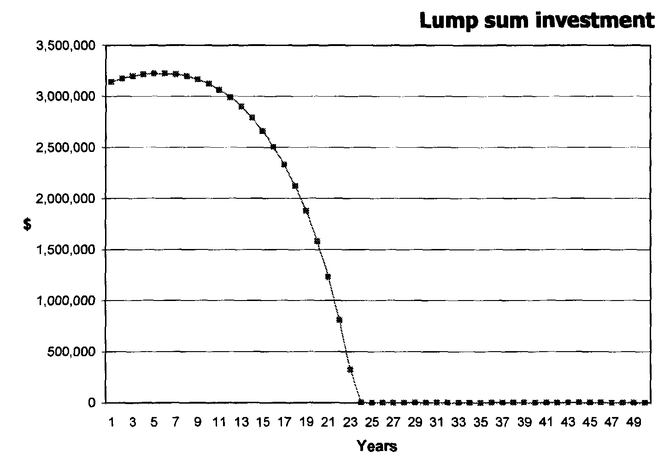
The large settlement sum quickly runs out
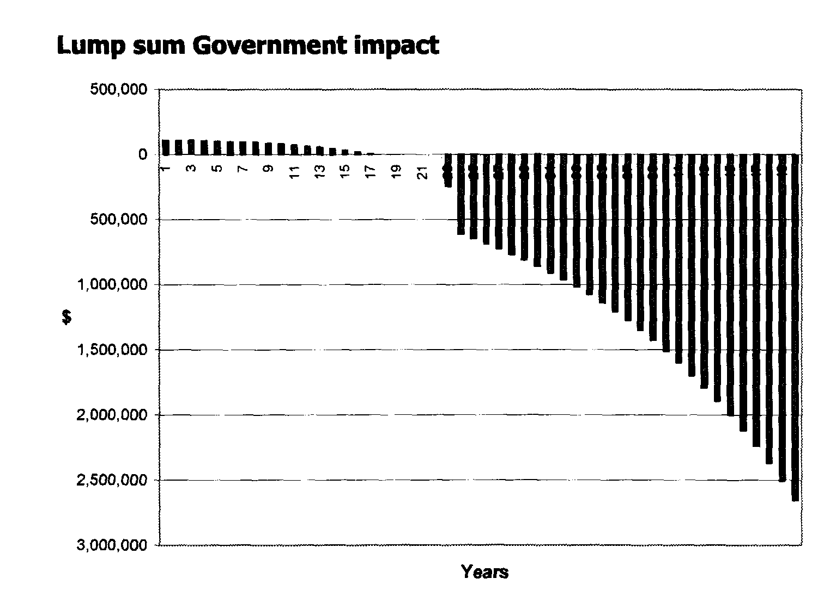

The cost of the welfare support greatly outweighs the small amount of revenue generated by taxing the investment component of the lump sum.

Structured Settlements - what the Government needs to do

WHAT THE GOVERNMENT NEEDS TO DO

Structured settlements should be made available as a compensation option in Australia.

The Government needs to provide an incentive so that injured people and the insurers handling their cases will adopt structured settlements in appropriate cases.
The most appropriate incentive is a tax exemption for structured settlement payments.

This would mean that claimants would have a real choice at the time of settlement between a tax-free lump sum and tax-free structured settlements.

WHY THE GOVERNMENT NEEDS TO ACT
The current lump sum compensation system in Australia is in need of reform because:
• Without reform the status quo will remain. Defendants will not offer periodic payments to claimants and claimants will not want them.

• The requested reform would improve the compensation system in Australia. Expanding compensation options and choice will enable a more effective matching of claimant needs with compensation payments.

• Structured settlements encourage claimants with long term needs to make sound, long term financial choices.

• Structured settlements give injured people much-valued independence.

• Defendant insurers will have the benefit of an additional tool to help them settle cases.

• All compensation stakeholders in Australia support the introduction of structured settlements as an option, including claimants, defendant insurers, lawyers and peak bodies. See page 15.

• Structured settlements reduce the long-term costs to government of personal injury through reduced Social Security and Health payments.

• Structured Settlements support other related Australian Government policies on income security and compensation. See page 16.

Structured Settlements - what the Government needs to do

STRUCTURED SETTLEMENTS

CASE STUDY: PART TWO

If "Sarah" had chosen to settle her claim on the basis of a structured settlement rather than a lump sum then her long-term financial situation would have been very different.
Instead of paying Sarah a lump sum of $3,143,364, the defendant insurer could have purchased an annuity that cost $3,034,606. This annuity would have matched Sarah's monthly cost of care for life (indexed to inflation) and the structured settlement would have been slightly less expensive for the defendant insurer than the lump sum settlement.
Structured settlement payments
The following diagram shows the annual payments that increase in line with CPI
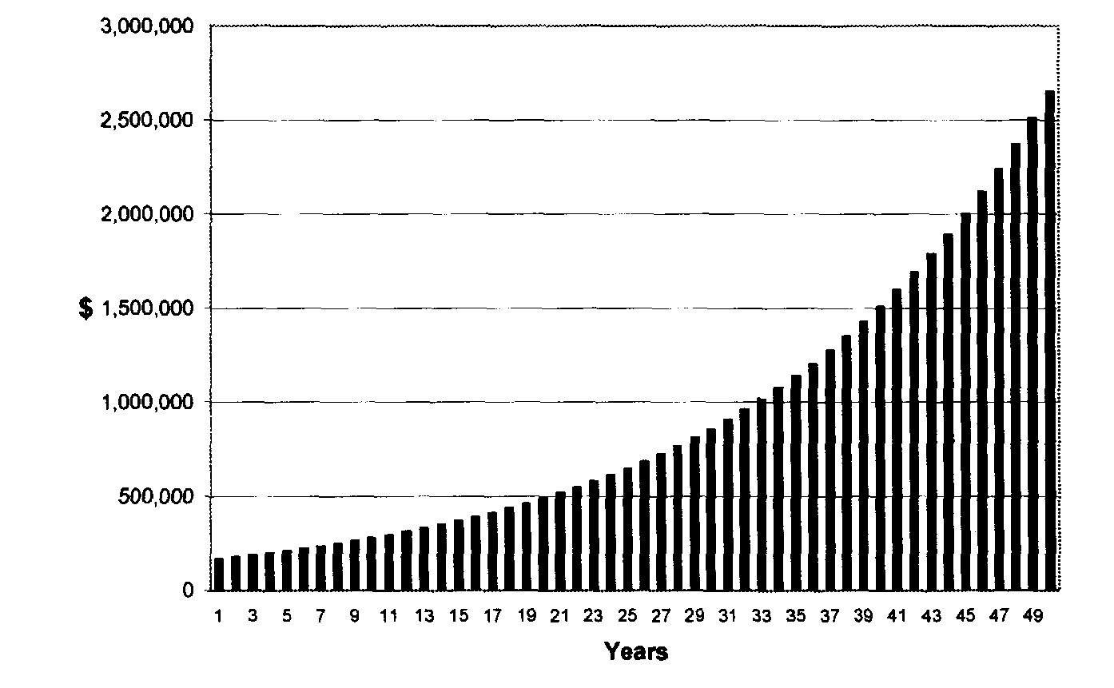
Comparison lump sum and structure
The following diagram shows the superiority of a structured settlement compared with a lump sum settlement over time.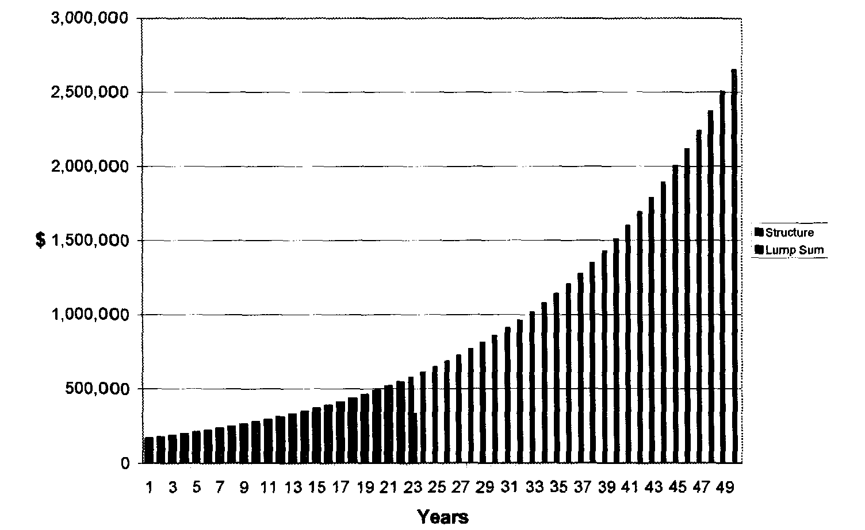

Structured Settlements - real life stories of lump sum problems

REAL LIFE STORIES

LUMP SUM MISMANAGEMENT RISKS

Lump sum compensation paid to accident victims often puts them at risk of being taken advantage of by relatives and friends. This story is from the Sydney Morning Herald on 8 June 1996.
A Victorian woman yesterday admitted that an addiction to gambling on poker machines led to her stealing $130,000 from her quadriplegic son's accident compensation payout.

Julia Lillian Davis, 53, told police she became addicted to poker machines after her husband died in 1993. Davis said she would spend about $3,000 a week gambling on poker machines.

"I just sort of got addicted to the pokies, couldn't keep away from them", Davis told police in an interview tendered to Melbourne Magistrates Court.

She said she knew she had "thieved" the money from her son, Warren Zandona, 26. "I have been an idiot. I have been addicted to poker machines", she said.

Davis, of Clarkefield, North-West of Melbourne, pleaded guilty to one count of theft between January 1994 and April last year. Prosecutors withdrew a further 223 theft charges against Davis. The magistrate, Mr Greg Levine, allowed Davis bail and ordered her to appear at the Victorian County Court in October.

Mr Zandona was left a quadriplegic - unable to move his legs or his fingers - as a result of a car accident in 1990.

PEOPLE DON'T ALWAYS MAKE GOOD INVESTMENT DECISIONS
The following story is based on an article published in the US Legal Times on 2 June 1997.
In 1973, Shirley Adams of Memphis, Tennessee gave birth to a daughter. Tiffany. Tiffany was born with brain damage, a condition that Ms Adams maintained was the result of medical malpractice by the attending physician and the hospital. Although mentally alert, Tiffany is physically handicapped and unable to speak clearly.
In 1980, just prior to the case going to trial, Shirley and her husband received a cash settlement of $250,000 from the insurance companies of the doctor and hospital. Despite the attorney's advice to segregate this money in a separate account and invest it prudently, Shirley says her husband spent the money on his own construction company, feeling that this would be a solid investment for the future.

Structured Settlements -real life stories of lump sum problems

During the mid-1980's however, his company incurred financial losses and the money to care for Tiffany was gone. By 1990, Shirley and her husband separated and in 1993, they divorced. She received no child support.
As mentioned in Part One of Tiffany's Story, the compensation paid for Tiffany's benefit in 1980 was all gone by the mid-1980's.

In 1987, Tiffany's wheelchair malfunctioned. A manufacturing defect caused the wheelchair to roll into the street, where Tiffany fell down face first. She suffered severe facial injuries.

This time. Tiffany's mother, Ms Adams, insisted that the settlement she received from the wheelchair manufacturer be in the form of a structured settlement. Today, eight years after the 1989 structured settlement, Ms. Adams is convinced of the benefit that structured settlements have brought to her life.

"Taking care of Tiffany is a full-time job and requires constant attention, not to mention the financial need," she says, "My structured settlement protects Tiffany from other people completely taking advantage of her for the whole amount of the settlement."

SATISFACTION WITH STRUCTURED SETTLEMENTS - ANN'S STORY

The following story is based on an article published in the UK Financial Mail on 10 November 1996.

Ann Stratford was 29 when her life changed irrevocably. Although time has helped, she still finds it painful to talk about the moment that confined her to a wheelchair and full time care for the rest of her life.

Ann, now 34, says: "It was December 1991 and I was on my way to work as manager of a Northampton clothing shop. My car broke down and I pulled into the roadside and put on my hazard lights. Unfortunately a lorry driver failed to see the vehicle and drove into the back of it. The impact broke my neck".

The past six years have been a mental and physical battle for Ann as she has struggled to come to terms with her injuries. She is paralysed from the chest down, cannot move her arms or make a fist with her hands and she still suffers intense neck and shoulder pain. She says "I'm the same person existing in somebody else's body".

After 15 months in hospital, her first need was to find somewhere to live. Her flat was unsuitable for a wheelchair user and, after entering a home for disabled people and hating it, she decided to buy a bungalow on the outskirts of Birmingham with an interim payment from the damages case brought against the lorry driver.

Structured Settlements - real life stories of lump sum problems

Like most personal injuries situations, her case dragged on. But last year an out-of-court settlement was agreed. Ann began to plan her financial future.

She says: "Muiris Lyons, my solicitor at Stewarts in London, was wonderful. He outlined all the options. He said I could put the money in the bank, go to an investment adviser or agree to a structured settlement from which I would receive a tax-free income for life. Although I was wary at first, a structured settlement soon made sense".

Lyons put Ann in contact with Alison Taylor of Chase de Vere Investments. She used 60% of the award to purchase a structured settlement through Scottish Widows, a life insurance company.

This will provide Ann with an index-linked tax-free income for life that will cover her care costs - she has a live-in carer - and living expenses. Taylor invested the remaining 40% in a mix of tax-efficient investments.

Ann says: "I have an independent spirit and the structured settlement has given me financial independence".

Structured Settlements - the economic case

THE ECONOMIC CASE FOR STRUCTURED SETTLEMENTS

The introduction of structured settlements will save the Australian Government millions of dollars and the more claimants who choose to take structured settlements the greater the public savings.

Coopers & Lybrand undertook a study in 1997 that provides some estimate of the financial impact of the introduction of structured settlements. The statistics are intended to be indicative only.
Thousands of claimants receive large compensation payments every year. Approximately 5660 claims each year receive a lump sum in excess of $100,000 in respect of personal injury.

These claims make up a small proportion of the total number of claims, but a very large proportion of the total settlement sums paid. These statistics give a rough indication of the potential number of accident victims who might be interested in a structured settlement.

Coopers & Lybrand have made some estimates of the current cost to the Australian Government associated with claimants exhausting lump sum compensation and then subsequently claiming welfare benefits.

The status quo costs the Government approximately $225m per year.

Coopers & Lybrand estimated that in any one year:

• The amount of revenue generated from tax on invested lump sums is $408m.
• The cost to the Australian Government in terms of Social Security and Health expenditure is $634m.
• The net cost to the government is $225m.

Their research was conservative as it assumed that injured people invest their lump sums and spend them slowly. Thus the true amount of tax revenue currently collected is likely to be lower, and the true cost to Government is likely to be higher.

Structured Settlements - the economic case

Structured Settlements would slash this cost

Assuming a 100% take-up rate of structured settlements in cases over $100k the following changes would occur:

• There would be a lower level of expenditure by the Government on social security and health.
• There would also be less tax revenue collected (as the interest component of structured settlement payments would be tax-free).
• The net cost to the government would be reduced from $225m to $6m - a saving to the government of some $219m.

While a 100% take-up rate has been used here, it is impossible to accurately predict the actual take-up rate. The 100% figure can however, be used to make rough calculations. Overseas, the take-up rate in the large cases has been around 30%. If this rate was achieved in Australia, the savings to the Government would be over $60m.
The adoption of the proposal would save the government some millions of dollars compared with the status quo.

Structured Settlements - unanimous support for structured settlements

UNANIMOUS SUPPORT FOR STRUCTURED SETTLEMENTS

All players involved in personal injury compensation actively support the introduction of optional structured settlements in Australia including claimants, lawyers and defendant insurers.

The following extracts highlight the support that exists for reform to encourage the use of structured settlements.
NSW Law and Justice Committee (1996):
• "The Committee recommends that, as a matter of some urgency, the NSW Government clearly states its support to the Commonwealth Government for the non-taxable status of structured settlements as a compensation mechanism, for the benefit of the long term financial independence and stability of compensable motor accident victims, and as a means of reducing the reliance of NSW motor accident victims on Commonwealth funded social security programs (otherwise known as double dipping)".
Victorian Law Reform Committee (1997):
• "...the Committee has recommended the introduction of structured settlements because of their benefit to those receiving compensation payments..."

• "Until such time as there is a degree of certainty as to the tax treatment of payments made under structured settlement arrangements, they cannot be attractive to persons injured as a result of services provided by a health service provider. An injured plaintiff will inevitably opt for lump sum compensation."
NSW Law and Justice Committee, The Hon. Bryan Vaughan MLC, Chairman (1997):
"Throughout the course of the committee's inquiry I became increasingly convinced that the lives of those who are most seriously injured in motor vehicle accidents...can be significantly assisted by the increasing use of structured settlements.

I am convinced that the time has come for Australia to follow the lead of the other great common law countries - the United Kingdom, Canada and the United States - and introduce structured settlements for very seriously injured accident victims."

"Together with the Standing Committee on Law and Justice, over the next few months I will be doing everything in my power to persuade representatives of government, accident victims, insurance companies and the legal profession of the considerable benefits of structured settlements. I promise that this will be a reform for which any parliament instrumental in achieving it will be long remembered."
Structured Settlements – unanimous support for structured settlements

NRMA Submission to NSW Law and Justice Committee (1998):

• "NRMA fully supports the concept of structured settlements and believes that structured
settlements have the potential to better tailor damages to suit the needs of the claimant while at the same time reducing settlement costs for insurers and reducing the social security burden on Government."

• "we believe the current tax situation has been clarified and it is not possible to
introduce structured settlements without changes to the current tax legislation. We are disappointed that we have no means of immediately making structured settlements available to claimants."

• In order to implement structured settlements the legislative model proposed by the
MAA now requires more urgent attention. We support this model and in particular support its approach of working within the current tax regime, which acknowledges the tax-free status of lump sums. We believe the model should be embraced and implemented by the Commonwealth Government without further delay."
Structured Settlements -policy support for structured settlement

POLICY SUPPORT FOR STRUCTURED SETTLEMENTS
Consistent with government policy
Structured Settlements are consistent with the Australian Government's efforts to encourage the greater use of periodic payments of compensation.
The Australian Government already uses tax policy to encourage periodic payments over lump sums. One example is superannuation, where tax is used to encourage retirees to take their superannuation funds in the form of periodic payments rather than a lump sum.
The Department of Family and Community Services has clearly articulated its broad policy of encouraging independence through long term income security and has stated that compensation paid in periodic instalments provides a more reliable source of income for injured people.
The Department has acted and has stated that it will continue to act to ensure that people who receive compensation payments use them for their support, at least for a reasonable period of time, before calling on the taxpayer funded social security system.

Recent proposed changes to the Department's rules relating to income streams and non-economic loss compensation have been made specifically in order to encourage long term periodic payment of compensation rather than lump sums.

These proposed new rules are unlikely to bring about any major shift towards periodic payments as the income stream rules apply only to those who have already elected to receive periodic payments, and the new non-economic loss rules only apply to pure non-economic loss payments. The vast majority of claims involving the seriously injured will involve both economic and non-economic loss compensation.

The new rules will have no impact on the primary disincentive to periodic payments - tax. Unless the tax law is changed most of the seriously injured will still prefer lump sum compensation.

Will not open floodgates

Many interest groups must regularly approach the government and request "tax breaks". The Australian Government is understandably cautious when considering tax concessions for specific groups in case precedents are set and the floodgates are opened.

Structured settlements are, however, a special case on the basis of strong policy and economic grounds.

The special tax treatment would only be available to those who have suffered personal injuries and who have elected to receive their compensation periodically. This group of people will be relatively small and will be comprised of seriously injured people.

Few other interest groups seeking tax concessions will be able to justify their call for "tax breaks" on such a significant social justice basis. Nor is their proposed change likely to be revenue positive for the Government.
Recent precedent decision
The Assistant Treasurer, Rod Kemp, recently announced an amendment to the Income Tax Assessment Act to exempt interest on back-dated compensation payments. This was a policy decision made by the government for the benefit of those who have suffered personal injuries and who face court delays in receiving court awarded damages.

This is a good example of the government making a policy decision to tax exempt part of a compensation award for personal injury. It demonstrates the government's recognition of the disadvantaged situation of the severely injured.

Conclusion

The Structured Settlement Group strongly urges the Federal Government to act now to bring about the introduction of structured settlements to Australia.
A minor amendment to the Tax Act is all that is required to benefit not only the severely injured but also the Government and all taxpayers (because the amendment will be revenue positive).

All compensation stakeholders, injured people, insurers and lawyers support this reform which will greatly improve the compensation system in Australia.

